City of Fall River

Massachusetts

Fall River
Commission on Disability

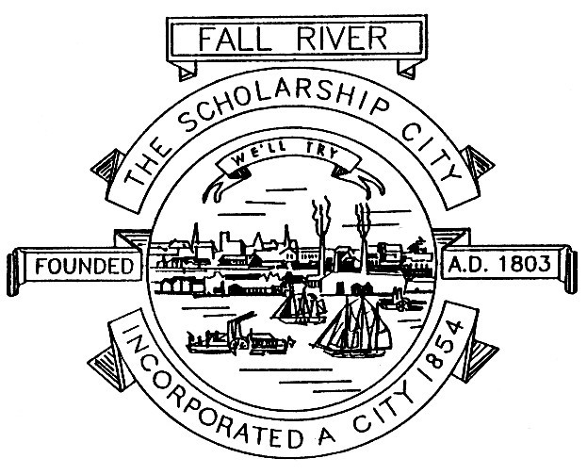

Paul E. Coogan
Mayor

Dennis Polselli
Chairman

Debbie Pacheco
Vice Chairwoman

AGENDA

FALL RIVER COMMISSION ON DISABILITY
CONFERENCE CALL MEETING
Dial in number for Commissioners and members of the public: 1-701-802-5485
Access Code: 832-3807 followed by the pound sign (#)
Wednesday, August 17th, 2022
3:30 PM
When the conference call meeting starts for clear communication and recording, please mute your phone by pressing star (*) 6. You can still hear the meeting but we can’t hear you. If you wish to speak press star (*) 6 to unmute. All votes will be taken by roll-call according to the open Meeting Laws.

- Reading of the Open Meeting Law Statement from the Open Meeting Law Guide.

- Roll-call: Sandy Berube, Senior Clerk, Health and Human Services

- Public Input.

- Approval of the minutes for the conference call meeting of Wednesday June 8th , 2022

- Budget for the 2023 Scholarship event for Saturday, June 3rd, 2023 including a deposit for decorations.

- Guest Presenter: LT. Nicholas Silva Fall River Fire Emergency Services: on a new program for seniors and individuals with Disabilities called “Fall River Cares.”

- Work Group Updates:

- ADA Update:

- Policies: Commission Vice-Chair Debbie Pacheco.

- Finance: ( See Budget Report for July, 2022 )

- Outreach: Lisa Silva and Dennis Polselli Scholarship program and updates.

- Old Business:

- New Business: Next meeting will be Wednesday September 14th, 2022 3:30 P.M.

- Adjournment:

To listen to a recording of the Commission on Disability Meeting call 1-978-990-5094. Then enter access code: 832-3807 followed by the (#) pound sign.

Health Department 508-324-2421

Commission website: http://www.frcod.org or: http://www.fallrivercod.org

